**DL -Lab 3**

**IT21202490-Kalhara N.V**

**Face 1**

**Face 2**

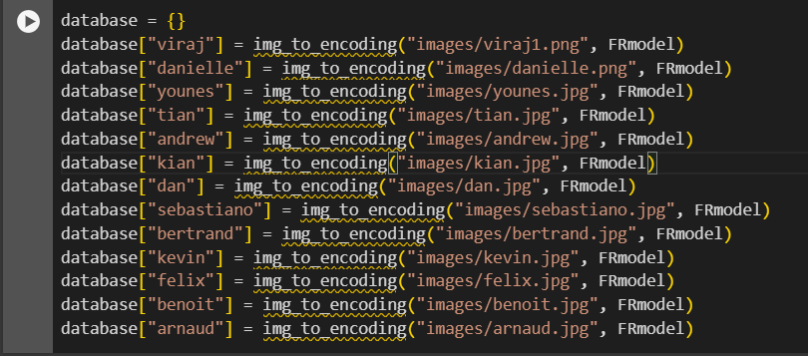

**Face verification**



**Face Recognition**

